APPENDIX I - TO PRODUCE BROTH CULTURES IN SIMPLE GLASS FERMENTORS*
Glass fermentors are set up in the laboratory and used for the small scale production of liquid inoculum. The inocula are monitored for cell number and contamination during growth.

Key steps/objectives

1) Initiate starter broth cultures
2) Assemble small fermentor units
3) Sterilize fermentors
4) Become familiar with operation details
5) Inoculate the fermentors
6) Take broth samples periodically for cell count and check for contamination
7) Test for contamination
8) Perform total counts and optical density measurements
9) Perform viable counts by the spread plate method on the presumptive test media
10) Perform agglutination tests with the homologous antisera

(a) Inoculating starter cultures

(Key step 1)

Prepare four 50 ml flasks or tubes each containing 25 ml of YM broth. Obtain slant or bead preserved cultures of a slow-growing Rhizobium (e.g., Rhizobium japonicum TAL 379) and a fast-growing Rhizobium (e.g., Rhizobium phaseoli TAL 182). Inoculate two flasks with each Rhizobium and aerate at 26 - 28°C. These will serve as "starter" cultures for inoculating the YM-medium in the fermentors.

(b) Assembling simple fermentors

(Key steps 2 and 3)

Set up 2 fermentors (1 for each strain) as shown in Figure 19.1. The main fermentation vessel is a slightly modified 4 liter Erlenmeyer flask with a sampling port (glass tubing 4mm ID) fitted close to its base. (The assistance of a glass blower is needed for this modification). Fill each fermentor with 2-3 liters of YM broth. Connect the cotton packed filters to prevent the entry of contaminants via the air lines. All rubber stoppers and tubings must be autoclavable. Insert the large rubber stopper which holds the air inlet and outlet tubes with their respective filters, firmly into the neck of the flask.
Figure 19.1. Scheme of simple fermentor unit

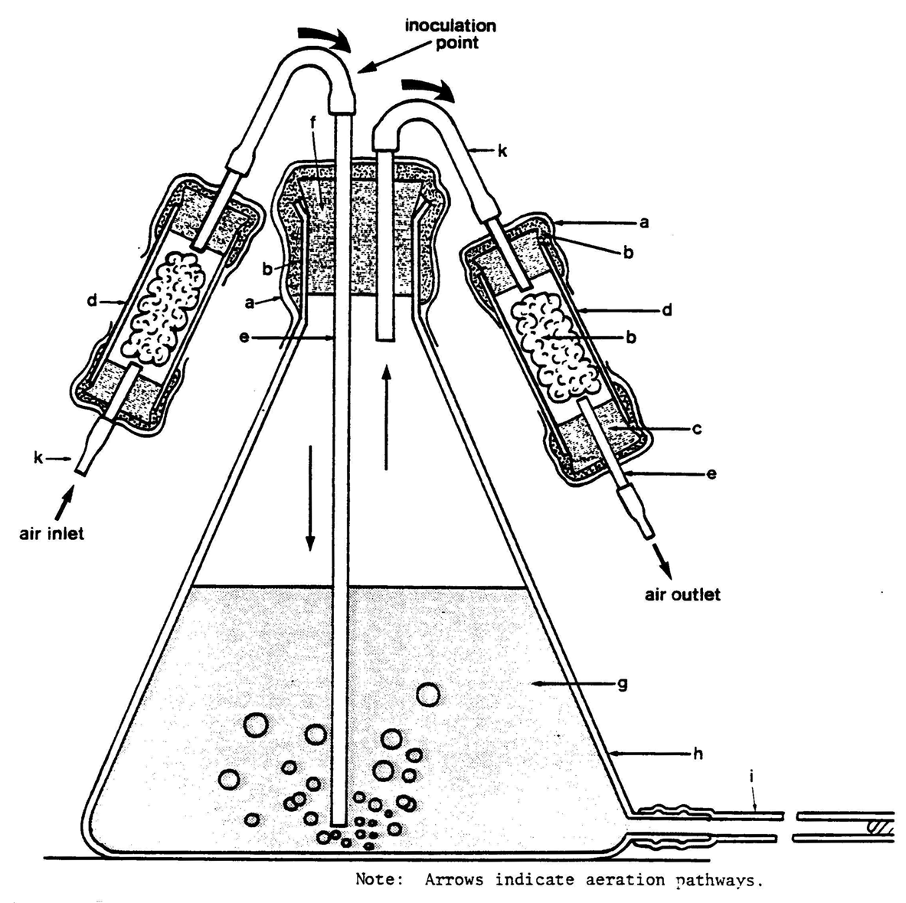

a - Aluminum foil: b - Nonabsorbent cotton: c - Autoclavable stopper: d - Filter unit:
e - Glass tubing: f - Autoclavable stopper: g - Growth medium: h - Flask: i - sampling tube: j - Plug: k - Rubber tubing
Figure 19.2 Simple Fermentor in operation

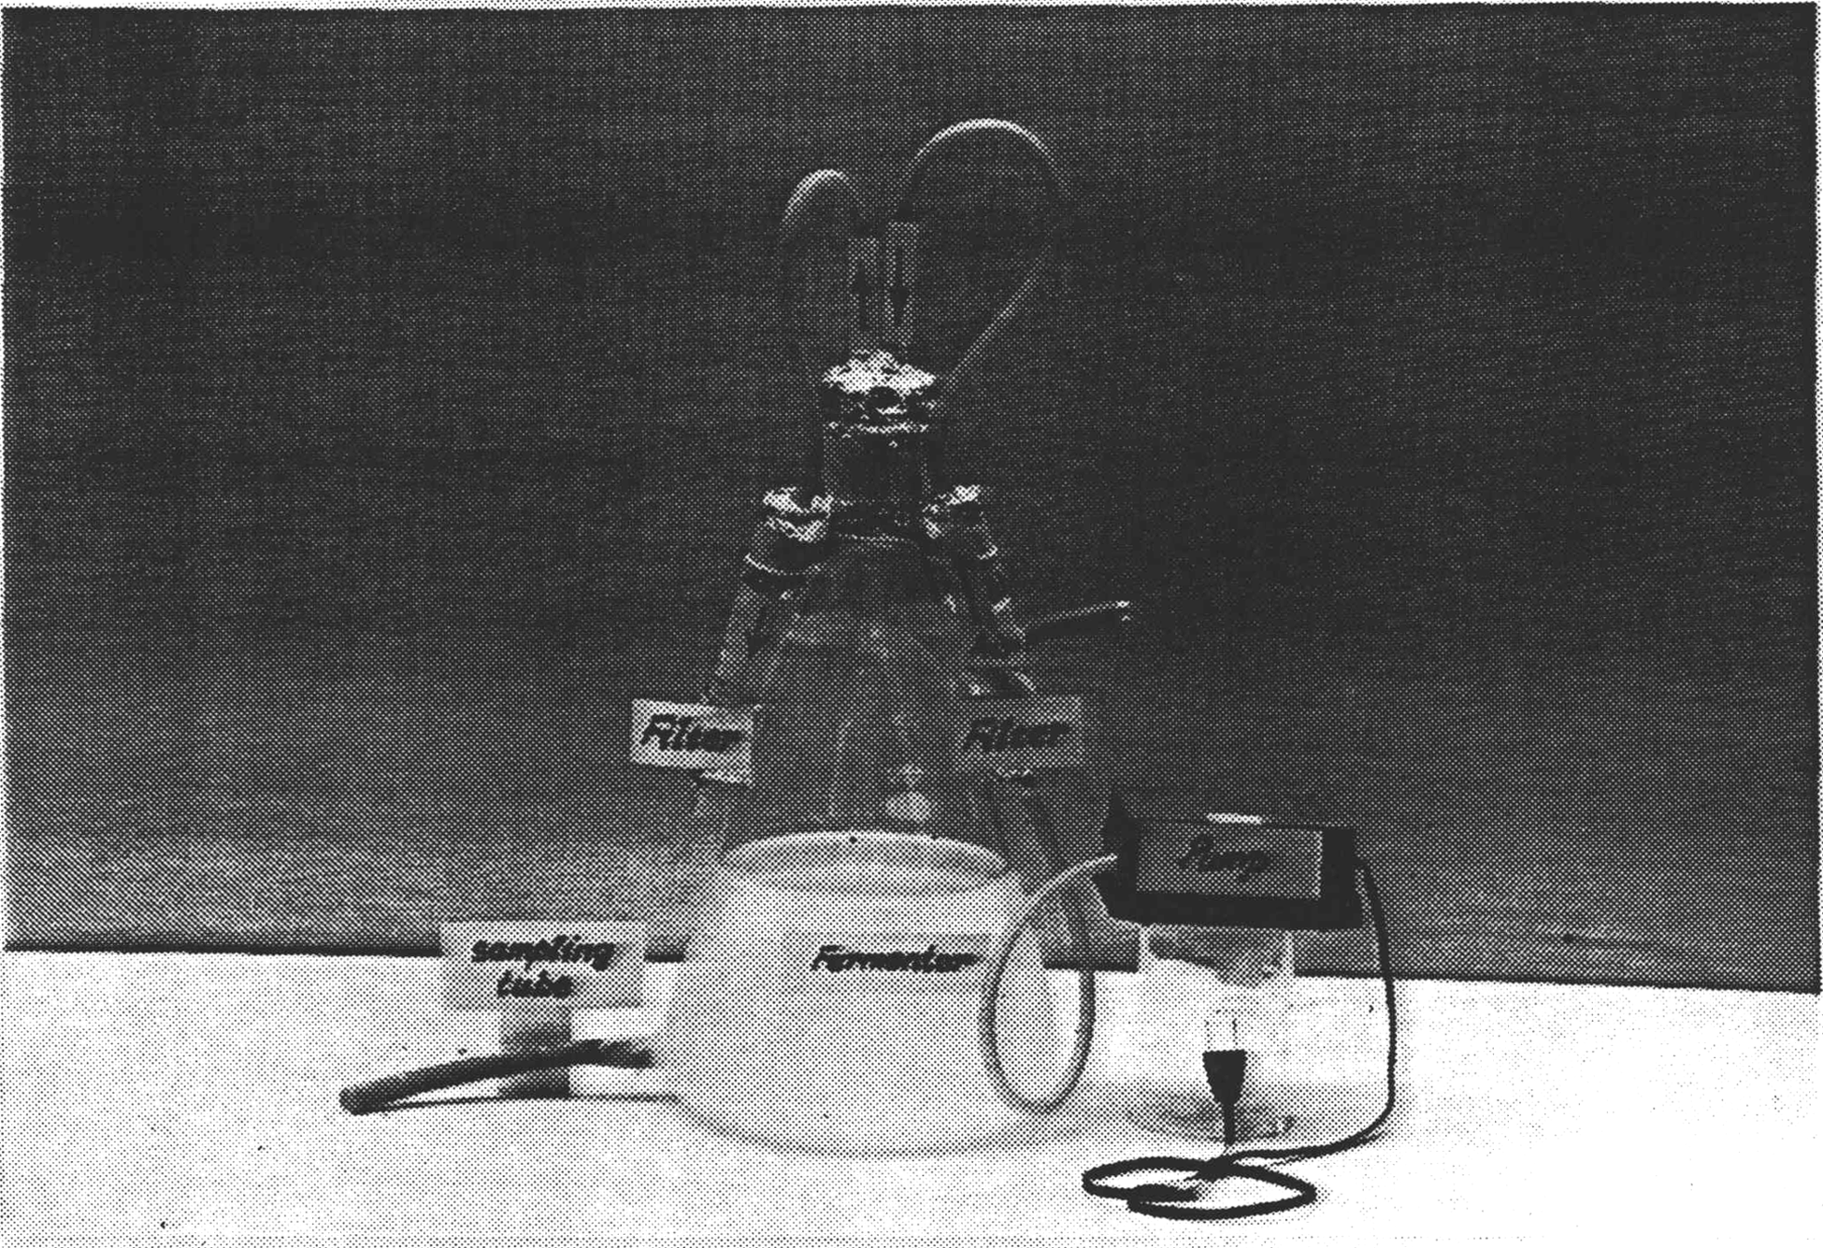
Connect the air inlet tube to an aquarium pump. Activate the pump and check the air inlet and outlet filters for air resistance. Air should flow freely through both filters while bubbling through the broth and aerating and agitating the medium. The cotton in the filters should be packed uniformly but loosely. Overpacking the air inlet filter can cause resistance to incoming air and lead to poor aeration. Overpacking of the outlet filter can lead to poor air escape and pressure build up in the fermentor.

Disconnect the fermentor from the pump and prepare it for autoclaving. Make sure that the stopper which holds the air tubes is still firmly seated. The air system must be well protected to prevent entry of contaminants. Wrap each flask with a wide band of non-absorbent cotton and secure with string. Add a protective wrapper of aluminum foil (Figure 19.2). Close the air inlet tube with a clamp at the spot indicated in Figure 19.1 to prevent the broth from leaving the flask due to pressure build up in the flask during autoclaving. Pressure relief during autoclaving occurs through the air outlet tube which must be left open. The filters should remain connected to the fermentor during autoclaving. To provide a convenient place for them, make an oversized wire ring around the neck of the fermentor vessel and twist it to an eyelet on each side. Each filter may then also be fitted with a piece of wire ending in a small hook. Hook the filters onto the eyelet (Figure of 19.2). Sterilize the assembly for one hour, if it contains approximately 2 liters of broth. Adjust the sterilization time according to the volume of liquid; increase time by 20 minutes for each additional liter.

After the fermentors have cooled, remove the clamp from the air inlet tubing. Connect the air supply to check for proper aeration once again and for leaks in the system.

Various types of air systems have been used to aerate small fermentors including compressors, compressed air in tanks, aspirators, and aquarium pumps. The latter have been very satisfactory air suppliers for small units. They are inexpensive, silent, and dependable. Although a pressure relief valve may be desirable, most aquarium pumps generate only low pressure sufficient however, for several fermentor units which may be connected to one aquarium pump using a manifold.

(C) Operating the glass fermentors

(Key step 4)

If, after autoclaving, each fermentor has been inspected and found to function properly, it is ready for inoculation with the starter culture. (If desired, the autoclaved fermentor may be left for 24 hours prior to inoculation for further check on sterility.) If an aquarium pump is used, and more than one fermentor is attached, adjust the air to achieve an equal flow to each fermentor. For other air supply systems, adjust the air flow on the bypass.

The glass fermentors are inoculated through the latex air inlet tubing with a sterilized syringe fitted with an 18 gauge needle. Care must be taken that no contaminants are introduced. Twenty ml of the starter culture are removed aseptically from its flask. The air inlet tubing is swabbed with 70% alcohol about one inch above its connection to the glass tube. The needle is inserted into the tubing pointing downwards toward the fermentor and the culture is injected. The airstream will facilitate speedy entry and incorporation of the inoculum into the YM medium. The culture is incubated at 26 - 28°C under continuous aeration.

(d) Collecting culture broth from the glass fermentor

(Key step 4)

The broth medium is withdrawn from the glass fermentor aseptically by swabbing the outflow tubing with 70% alcohol and inserting a syringe needle attached to a sterile syringe. For quality control purposes, such a gram stain, pH measurements, optical density measurements, the total count, and plate counts, 5-10 ml are sufficient and may be withdrawn by using a 5 or 10 ml syringe equipped with a 22 gauge needle.

For injection of the broth culture into bags of sterile carrier (peat), to ml samples are usually withdrawn with a sterile 50 ml syringe and an 18 gauge needle. Alternatively, an automatic motorized syringe equipped with a 16 gauge needle may also be used if large numbers of bags are to be injected.

In another modified system, a 1 liter collection flask is connected to the fermentor as shown in Figure 19.3. This collection flask should be autoclaved together with the fermentor. It is connected to the fermentor via a tubing which is attached to a sampling tube which runs through the stopper on top of the unit into the broth culture. A sampling port at the bottom of the fermentor is not needed in this case. The broth culture is forced into the sampling flask by closing off the air outlet of the fermentor while the pump is running.

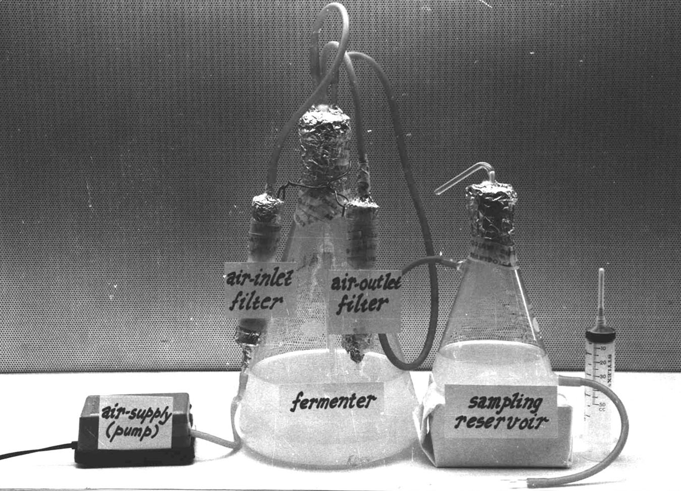

Figure 19.3. Modified fermentor

(e) Producing broth inoculum (Key steps 5, 6, 7, 8, 9, and 10).

When the starter cultures have reached the end of their log phase of growth (7 days for a slow-growing Bradyrhizobium and 5 days for fast-growing Rhizobium) they are ready to be used for inoculating the fermentor.

Inoculate one fermentor with the slow-growing Bradyrhizobium (e.g., B. japonicum TAL 379) and the other with the fast-growing Rhizobium (e.g., Rhizobium phaseoli TAL 182).
From both fermentors take a 10 ml sample at regular intervals once a day for 7 days and conduct the following tests:

1) pH measurement-a contamination problem is usually evident when the pH of the broth decreases toward acidity especially with slow-growing alkali producing rhizobia (e.g., B. japonicum). However, with fast-growing, acid producing rhizobia (e.g., Rhizobium phaseoli) the pH test is less helpful since most contaminants are usually acid producers. Test the broth pH by adding two drops of bromthymol blue(0.5% in alcohol) in 1 ml broth. A yellow coloration indicates acidity and a blue coloration alkalinity.

2) Gram stain (Exercise 3)

3) Peptone glucose test (Exercise 3)

4) Total count with Helber or Petroff-Hausser counter (Exercise 4)

5) Optical density measurement (Exercise 4)

6) Spread plate count on YMA containing Congo Red and on YMA containing BTB (Exercise 4)

7) Agglutination with the homologous antiserum

This should be done just before harvesting when the culture has no less than 1 x 109 cells per ml. Dilute 2 ml of the cell suspension with 2 ml saline. Mix well and heat in boiling water for 30 minutes. After cooling, pipette 0.5 ml into an agglutination tube and add 0.5 ml of a 1:50 dilution of the homologous antiserum which should have a titre of at least 800.

Perform the agglutination test as described in Exercise 6.

The broth cultures may be incorporated into carrier material when the 1 x 10⁹ cells per ml and purity of culture has been established.

Requirements

(a) Inoculating starter cultures

Transfer chamber
Platform shaker
Inoculation loop, flame
Erlenmeyer flasks or screw capped tubes of 50 ml capacity containing 25 ml YM
broth each.

(b) Assembling simple fermentors

Large autoclave, aquarium pumps or compressor
Cork borer, small glass file, bunsen burner
For each fermentor:
Erlenmeyer flask, 4 liter, (This flask is modified by the addition of an outflow
tube (ID 4 ml) at its base. These modified flasks are not available commercially, but any glass blower should be able to attach the short 3-5 ml glass tube.)
#12 autoclavable stopper
Glass tubing, inside diameter (ID) 4 mm, approximately 120 cm
Glass tubing, ID 30 mm, 2 pieces of 10 cm length for making air filters. Barrels of 50
ml syringes may be cut to size and used instead.
Rubber stoppers #4, autoclavable, 4 pieces
Hose clamps, 2, T-piece
Surgical rubber tubing, ID 4 mm, approximately 150 cm
Glass wool, Cotton wool, non-absorbent, Aluminum foil
Sampling tubes, ID 4 mm
YM broth (2-3 liters)

(c) Operating the glass fermentors

Syringes (30 ml), sterile with 18G needles
70% alcohol, cotton swabs or tissue paper
Broth culture of Bradyrhizobium japonicum TAL 379
Broth culture of Rhizobium phaseoli TAL 182

(d) Collecting the culture broth from the glass fermentor

Syringes, sterile (10 ml); 22G needles
Test tubes, sterile (for samples)

(e) Producing broth inoculant

Spectrophotometer; cuvettes, transfer chamber
Antisera homologous to the strains used (e.g. TAL and TAL 182)
Plates of peptone glucose agar
Plates of YMA containing BTB
Plates of YMA containing Congo Red
Syringes (20-30 ml); 22G needles
Test tubes, sterile (for samples)
Pipettes, sterile (1 ml); pipettes, sterile (10 ml).
Dilute tubes containing 9 ml sterile diluent, rack
Pasteur pipettes, sterile, calibrated
Solution of Bromthymol Blue (0.5% in ethanol)
Materials and supplies for Gram stain (Exercise 3)

* *Taken from exercise 19 of the NifTAL Manual for Methods in Legume-Rhizobium Technology, by P. Somasegaran and H. Hoben.

